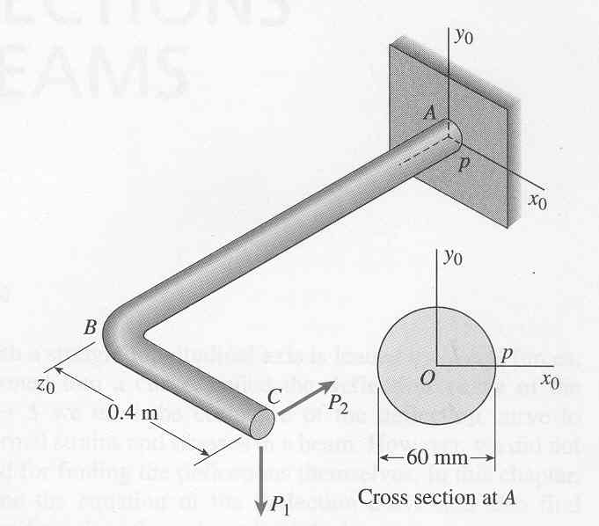A horizontal bracket ABC consists of two perpendicular arms AB and BC, the latter having a length of 0.4 m. Arm AB has a solid circular cross section with diameter equal to 60 mm. At point C a load P1=2.02kN acts vertically and a load P2=3.07kN acts horizontally and parallel to arm AB. Considering only the force P1 and P2, calculate the maximum tensile stress σT and compressive stress σC, and the maximum in-plane shear stress τmax at point p, which is located at support A on the side of the bracket at midheight.

“Mechanics of Materials,” Gere & Timoshenko, 4th ed.